Data Visualization

* Which questions can be clustered with other questions? Like, for this question: Which of the following apply to you? Look only at the 69 people who responded, "I haven't made changes yet but I'm thinking about it." How did this group respond to ANY of the other questions?

The question “How do you perceive the convenience of using reusable period products?” can be clustered with the above question to get the relationship of how reusable period products are perceived by different groups of individuals on their perception of seeking eco-friendly period product options. In addition to that, the other question would be “What is the primary concern when it comes to period products?”

From the analysis, the primary concern of both those seeking eco-friendly options and those who have never considered eco-friendly options is having period products that provide leakage protection as shown by the figures below.

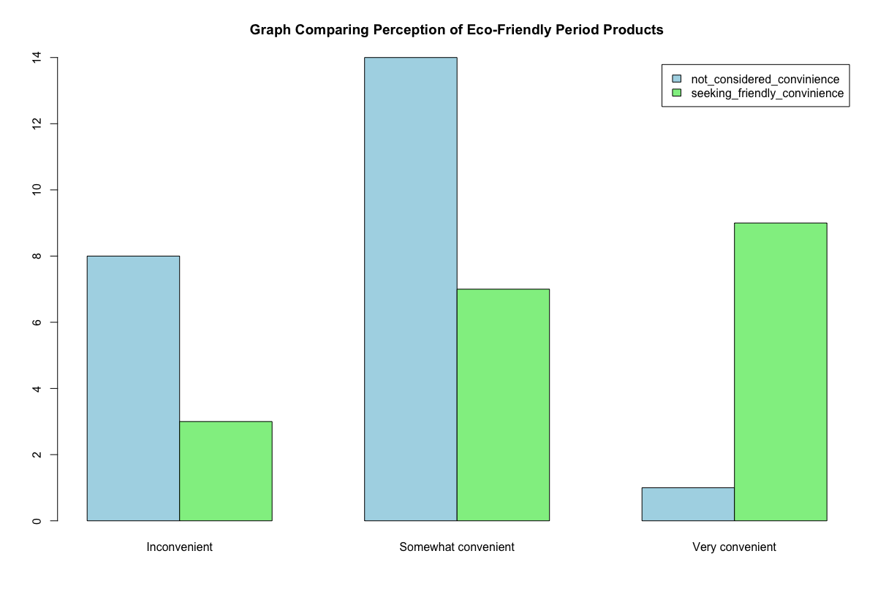

Majority of the individuals have not considered changing to eco-friendly options. In addition to that, a large percentage of the individuals who have not considered changing, perceive eco-friendly period products to be somewhat convenient. On the other hand, majority of the individuals who are seeking eco-friendly period products perceive them as being very convenient.

* Which campuses are dominant in the "Not Concerned" category?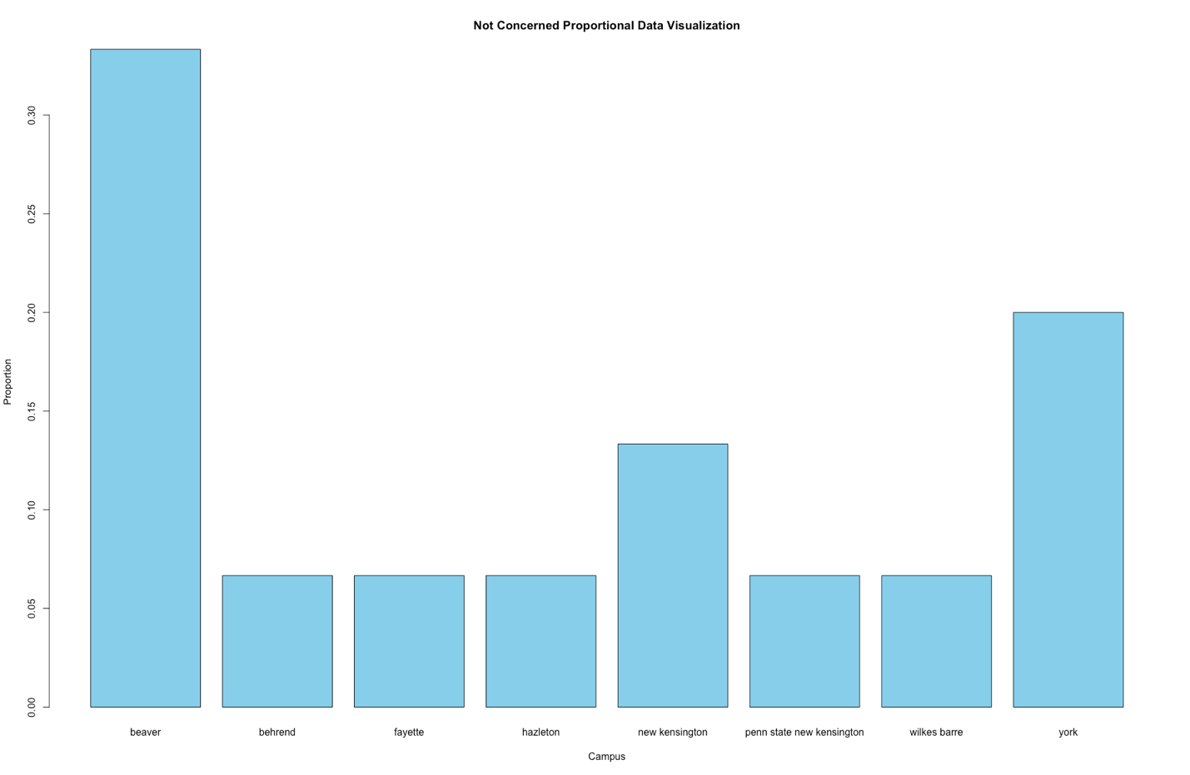

Beaver

* Which campuses are most dominant in the "I am concerned" category?

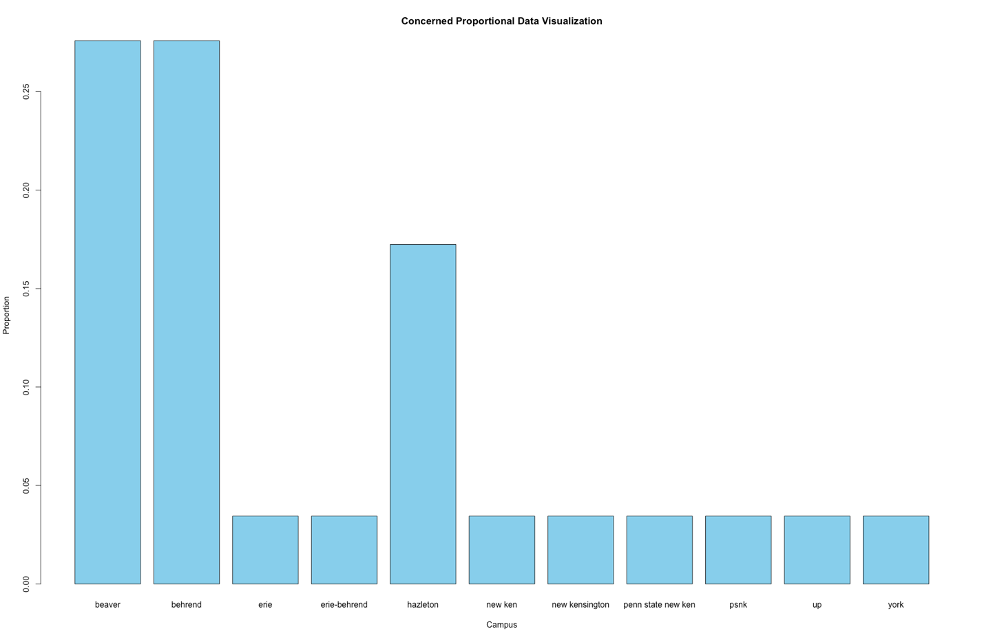

Beaver and Behrend

* How are the campuses represented proportionally in each case?

